- Check if string is empty
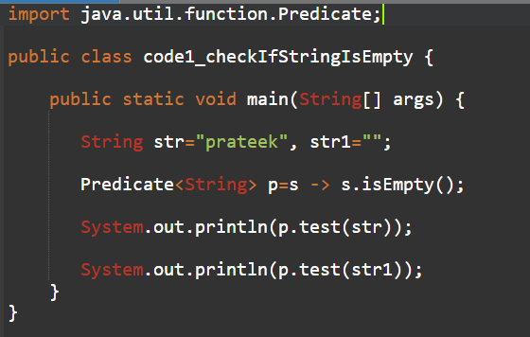

- Check if string is digits
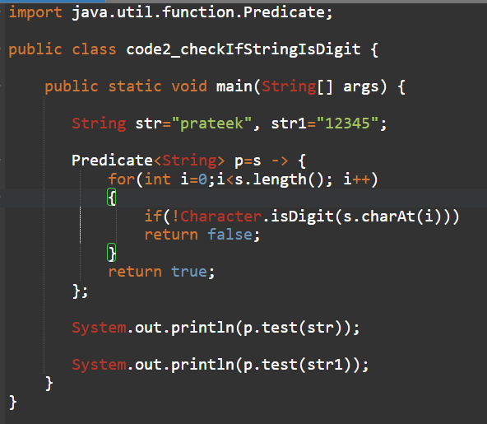

- Filter out names that start with a vowel from a list.
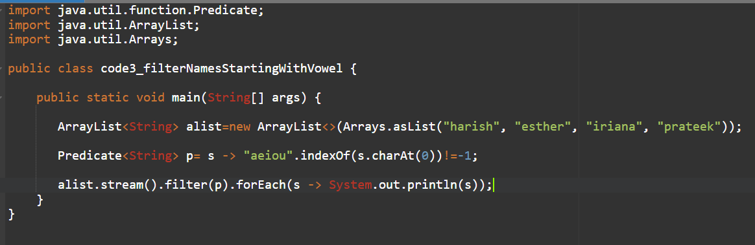

- Validate if a number is prime.
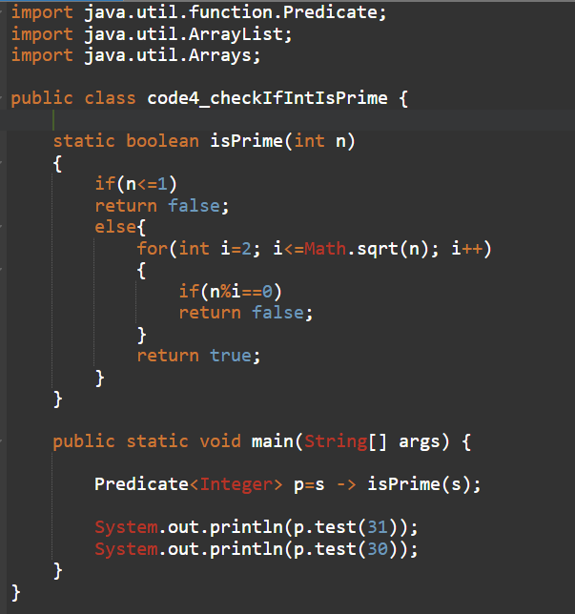

- Check if a password meets complexity rules (length, digit, special char).
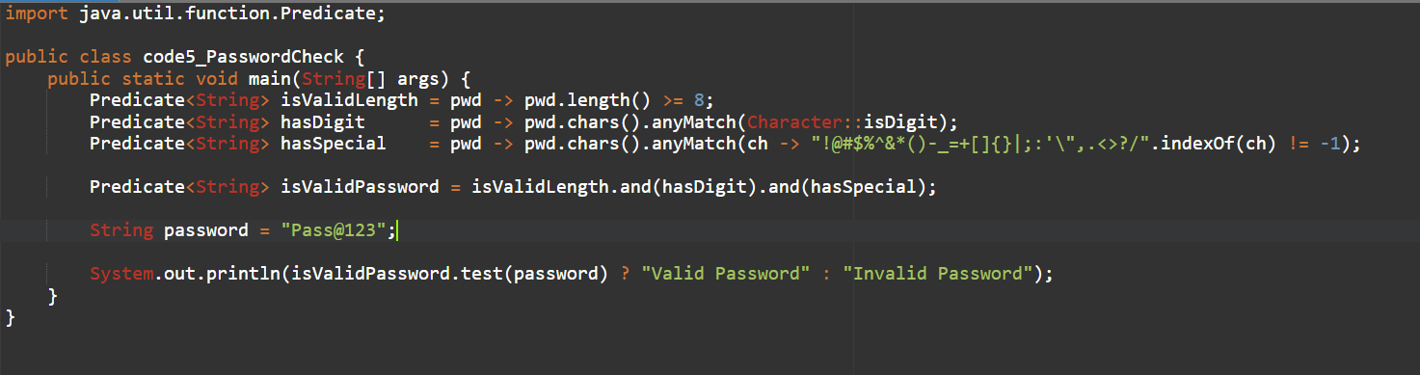

- Convert a list of strings to their lengths.
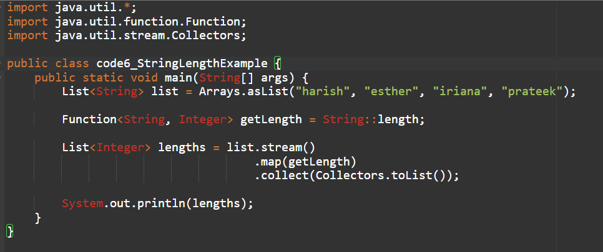

- Map employee names to their uppercase versions.
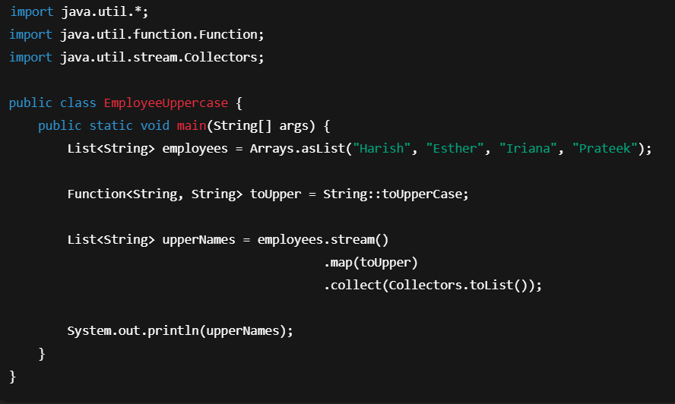
- Parse a date string "2025-08-08" into a LocalDate.
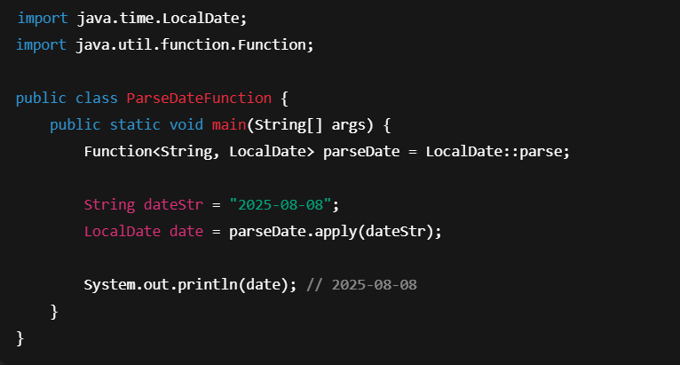

- Convert Celsius temperatures to Fahrenheit.
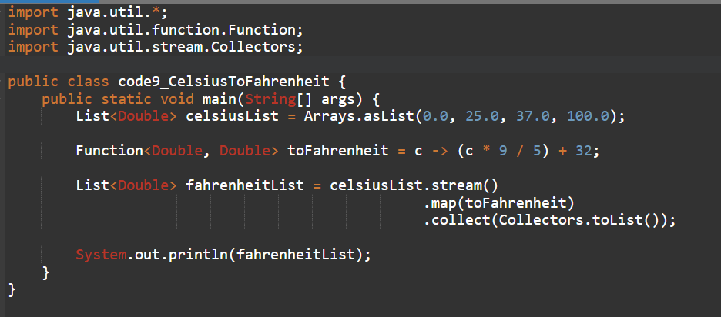

- Print each item in a shopping list with numbering.
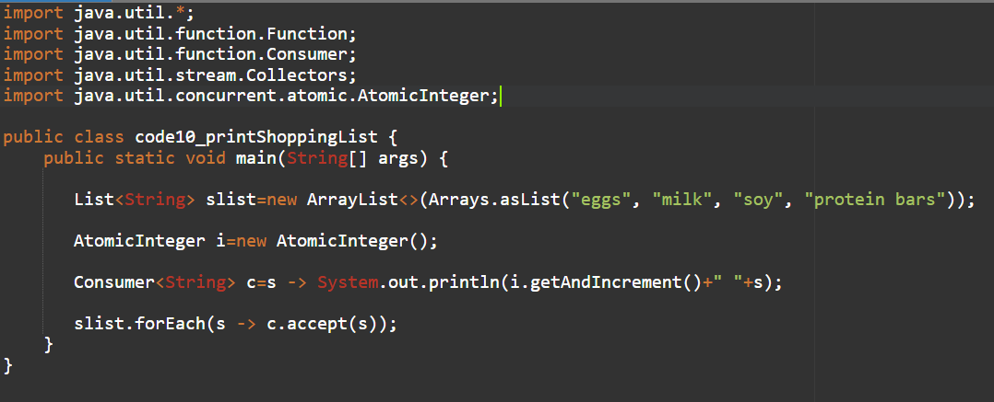

- Log all error messages in uppercase.
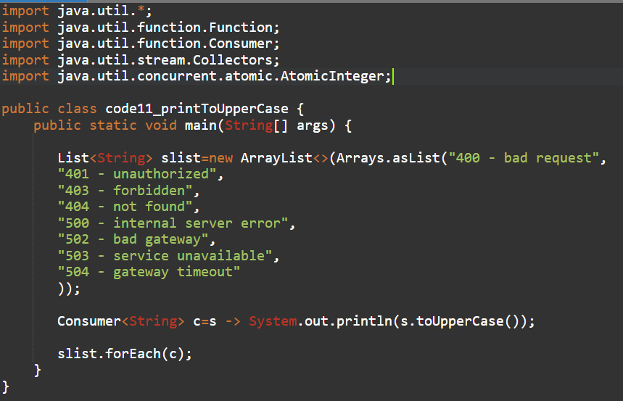

- Logging System Events
Write a program that takes a list of system events (strings) and uses a Consumer<String> to:
- Print each event with a timestamp.
- Log it to a file simultaneously. (Hint: chain Consumers with andThen())
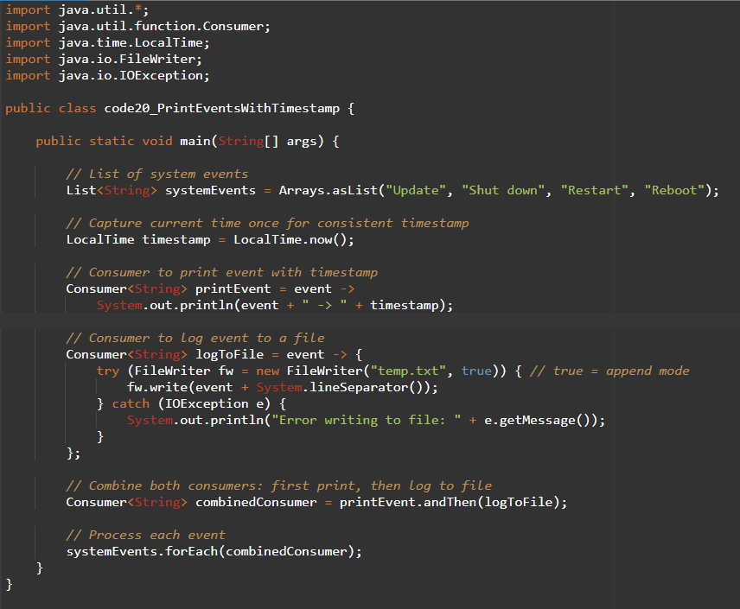

- Order Processing Pipeline
Given a list of orders (objects with id, item, price), use a Consumer<Order> to:
- Print order details.
- Apply a discount if the price > 1000.
- Send a confirmation message. (Hint: multiple Consumers chained)
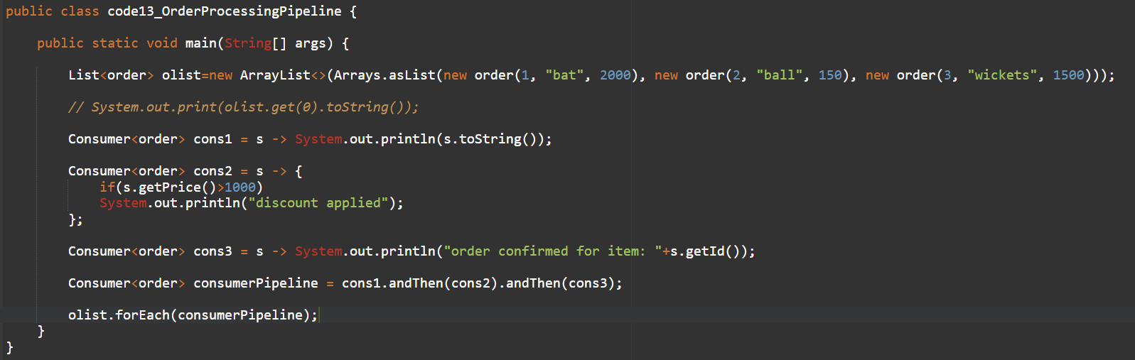

- Shopping Cart Checkout
Simulate a shopping cart checkout process where Consumer<List<String>> is used to:
- Print all items in cart.
- Remove unavailable items.
- Print total bill after modifications.

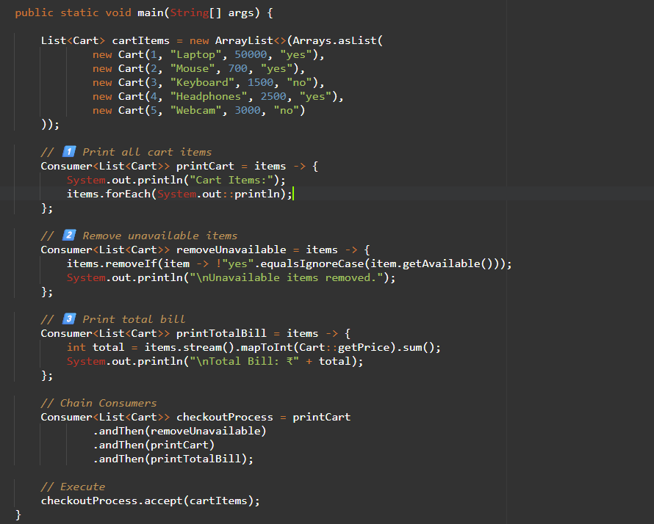

- Employee Salary Update
Given a list of employees (name, salary), use a Consumer<Employee> to:
- Increase salary by 10% if salary < 50,000.
- Print updated employee details.
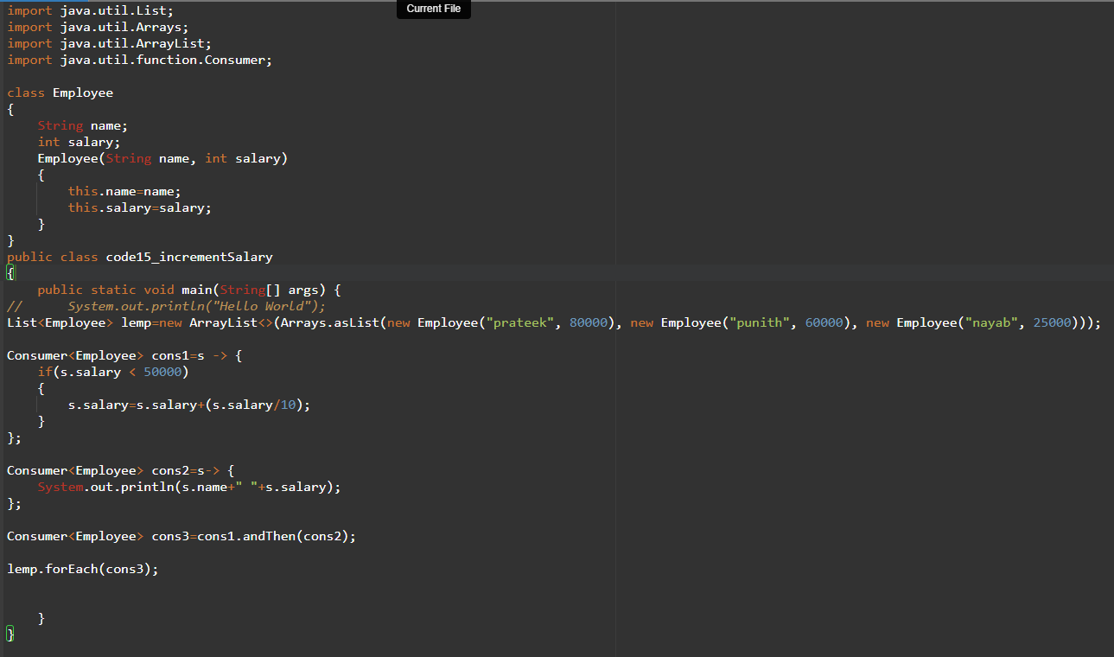

- Chained Notification System
Write a program where Consumer<String>:
- Sends a notification to the console.
- Writes the notification to a log file.
- Sends the notification to an API endpoint (simulate HTTP POST).
import java.util.List;
import java.util.Arrays;
import java.util.ArrayList;
import java.util.function.Consumer;
import java.time.LocalDateTime;
import java.io.FileWriter;
import java.io.IOException;
import java.net.URI;
import java.net.http.HttpClient;
import java.net.http.HttpRequest;
import java.net.http.HttpResponse;

public class code16_sendNotificationToServer
{
public static void main(String[] args) {

LocalDateTime lt=LocalDateTime.now();

Consumer<String> cons1=s->System.out.println(s+" "+lt);

Consumer<String> cons2=s->
{
try(FileWriter fw=new FileWriter("log.txt", true))
{
fw.write(s+" "+System.lineSeparator());
}
catch(IOException e)
{
System.out.print(e.getMessage());
}
};

Consumer<String> cons3=s->
{
try
{
HttpClient client = HttpClient.newHttpClient();
HttpRequest hreq=HttpRequest.newBuilder()
.uri(URI.create("https://httpbin.org/post")) // Test API
.header("Content-Type", "application/json")
.POST(HttpRequest.BodyPublishers.ofString("{\"notification\":\"" + s + "\"}"))
.build();
HttpResponse hres=client.send(hreq, HttpResponse.BodyHandlers.ofString());

System.out.println(hres.statusCode());
System.out.println(hres.body());
}
catch(Exception e)
{
System.out.print(e.getMessage());
}
};

Consumer<String> cons4=cons1.andThen(cons2).andThen(cons3);

cons4.accept("hey prateek");

}
}

- Create a generic method that accepts a Predicate<T> to filter any list type.
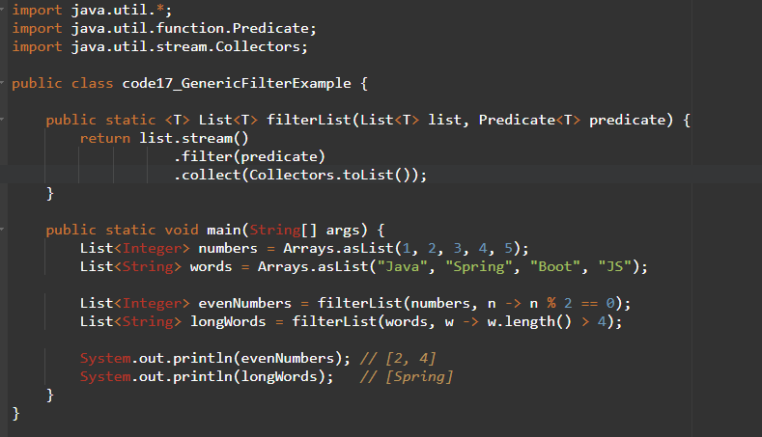

- Stream from different types
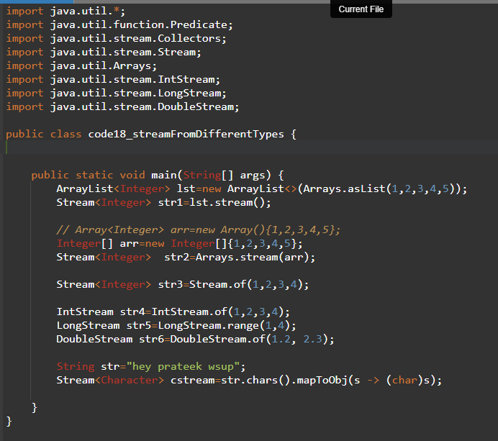

BiPredicate

- Check if two strings are anagrams.
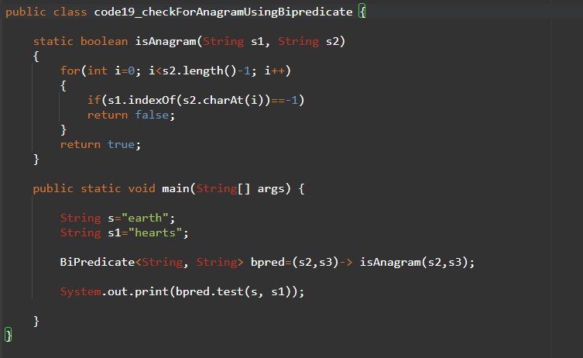

- String operations using Function
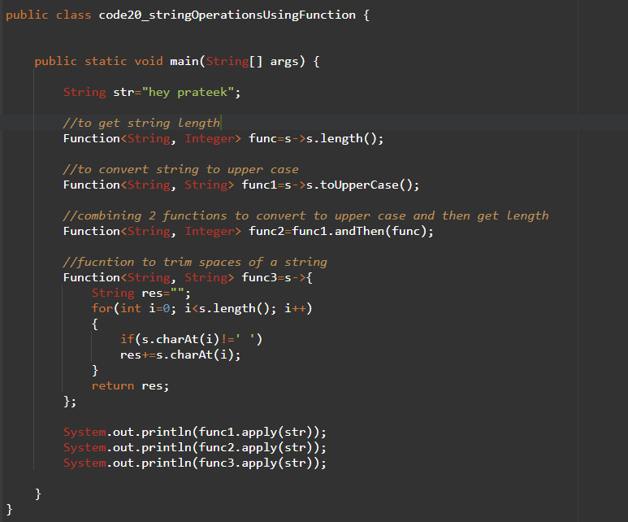

- Create a generic method that applies a given Function to each list element.
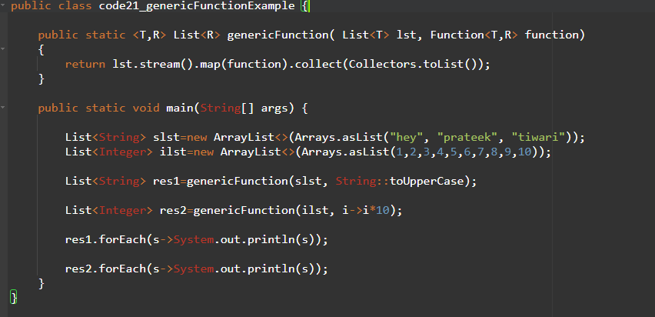

- Write a generic method that takes a BiFunction for merging any two lists.
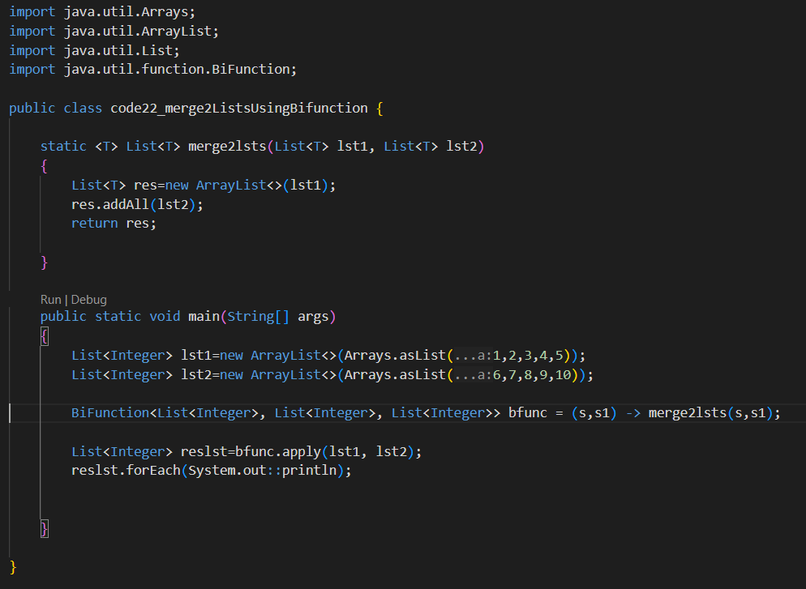

Supplier

Supply a random number between 1–100
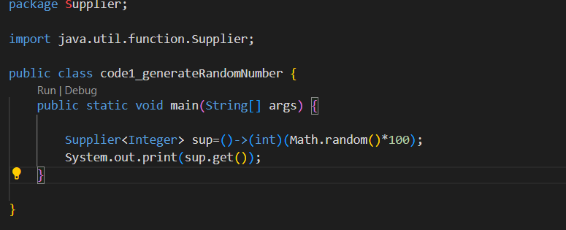

Supply the current date/time.
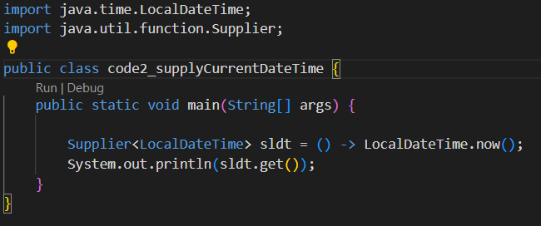

Supply a new unique ID (UUID).
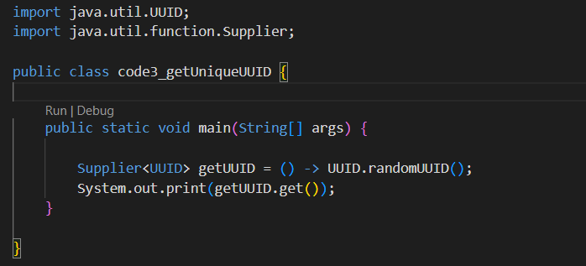

Supply a random password of length 8.
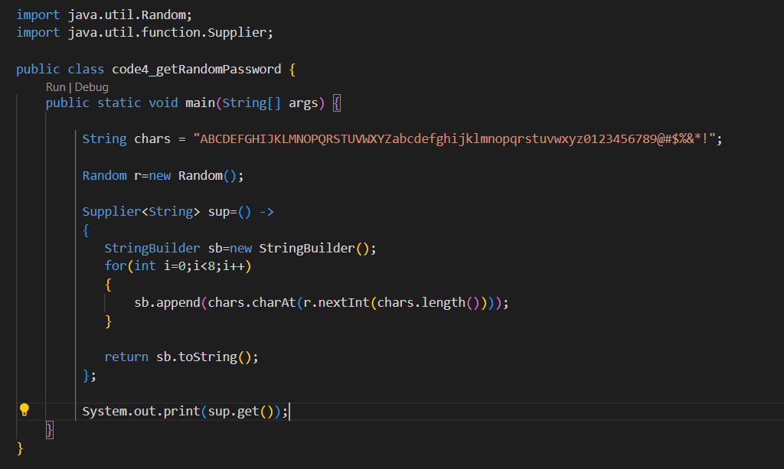

All combined

Read a file line by line → filter lines using Predicate → transform using Function → print using Consumer.

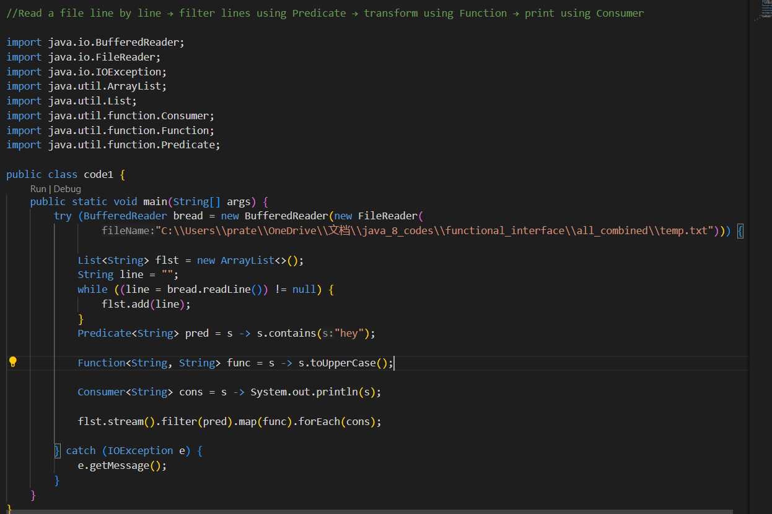

Use Supplier<List<Integer>> to generate random numbers, filter evens with Predicate, double them with UnaryOperator, and print with Consumer.
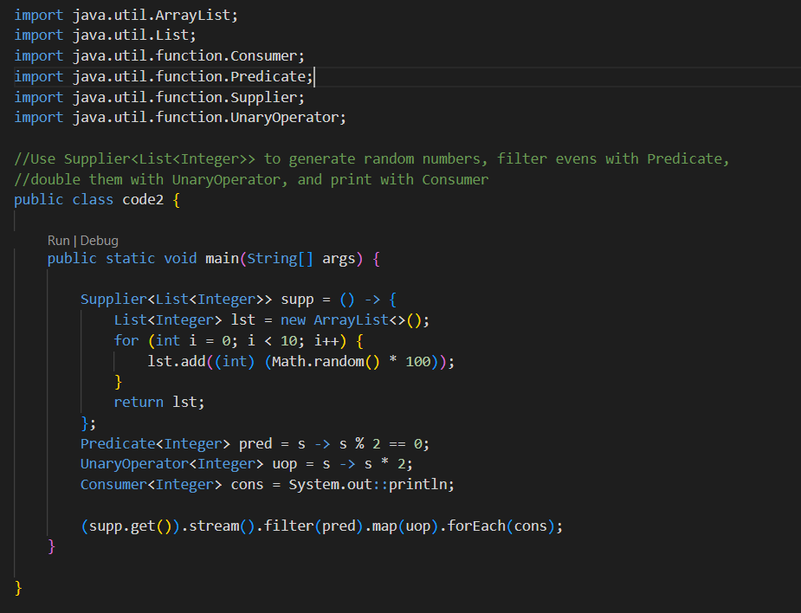

Chain Functions to transform a sentence: lowercase → remove punctuation → split into words → count words
